You can choose any methods to setup your task.
Method1: Options you have to enter value when do not use phone verification before run:
- UserInfoTable: enter data fro these options. The data you entered here are the same as when you register Twitter account manually in web.
Eg:
FullName: Steve Forbs
UserName: Your full Gmail address (eg: Steveforbs@gmail.com)
Password: 123456
Email_Password: Your Gmail password (eg: 123456)
Server: imap.gmail.com
Port: 993
Protocol: IMAP
SSL: YES
- TableProxy: please buy http proxy. One proxy per row. We do not sell proxy, if you need, we can recommend a proxy website to you. Usually this option is optional, but we still suggest you enter proxy to register. Because this can increase the ratio of success to register account.
http://www.squidproxies.com/
- ConfirmEmail: enter 1 or 0. 1 must verify the email address. 0 do not need to verify the email address.

Method2: Options you have to enter value when use phone verification before run:
- mustVerifyPhone: enter 1 or 0. 1 must verify phone. 0 do not need to verify phone.
- strSMSPvaAPIKey: register an account in smspva website (http://smspva.com/), then charge for your account, then you can find your account apikey in your account profile.
- UserInfoTable: enter data fro these options. The data you entered here are the same as when you register Twitter account manually in web.
Eg:
FullName: Steve Forbs
UserName: Your full Gmail address (eg: Steveforbs@gmail.com)
Password: 123456
Email_Password: Your Gmail password (eg: 123456)
Server: imap.gmail.com
Port: 993
Protocol: IMAP
SSL: YES
- TableProxy: please buy http proxy. One proxy per row. We do not sell proxy, if you need, we can recommend a proxy website to you. Usually this option is optional, but we still suggest you enter proxy to register. Because this can increase the ratio of success to register account.
http://www.squidproxies.com/
- ConfirmEmail: enter 1 or 0. 1 must verify the email address. 0 do not need to verify the email address.

How to create the task?
- Click this character “+” to create a task, then just name it:
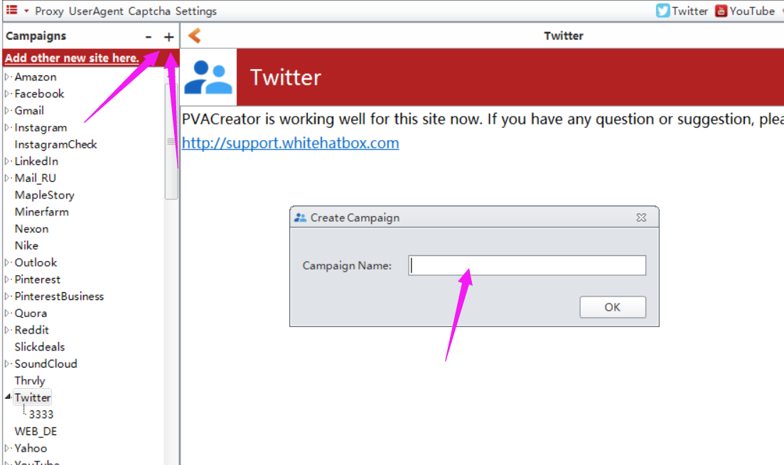

How to enter value for these options?
1. manually input value for them one by one.
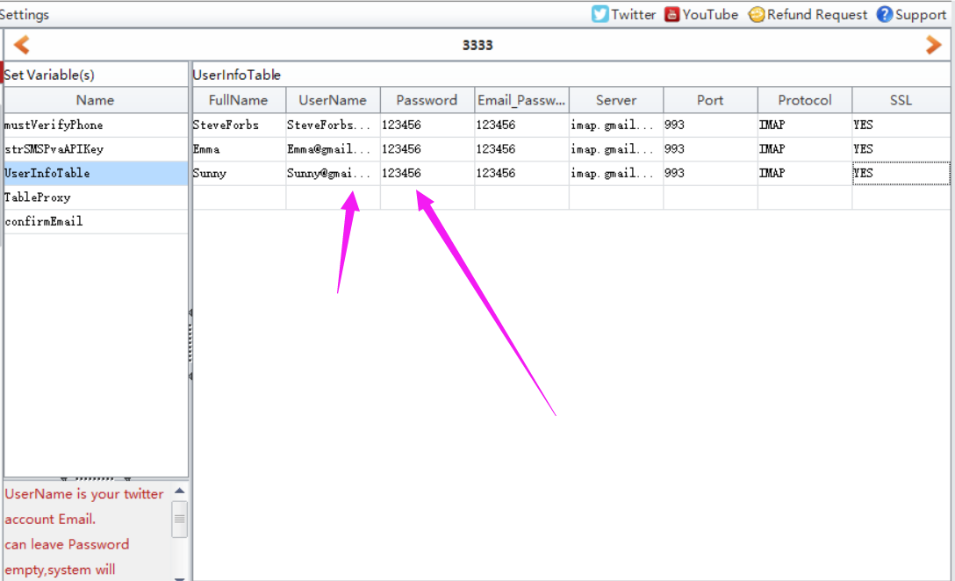
- click “BindData” to choose “Import from file” option to upload multiple data at a time.
Note: please check this column (the checked column color will be yellow) first which you need to multiple upload data.
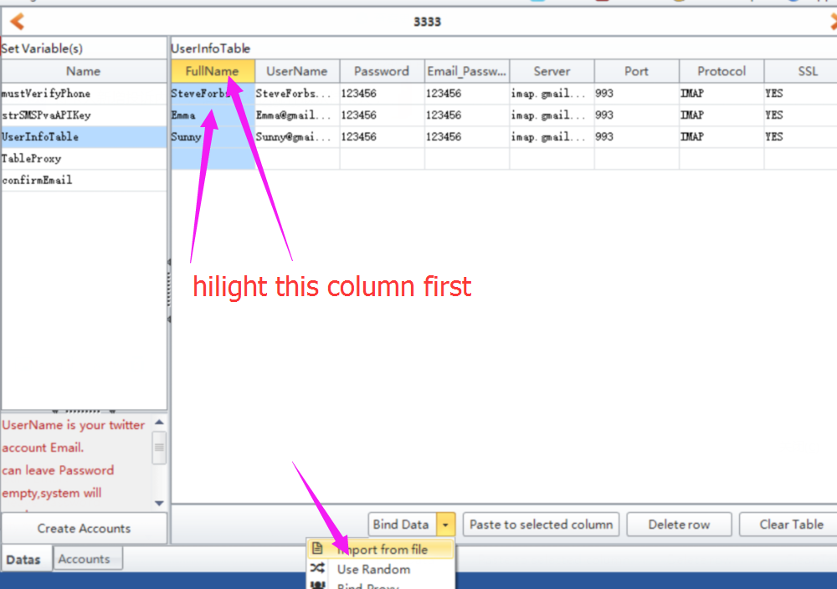
- click “BindData” to choose “Use Random” option to auto generate some data based on the condition you preset.
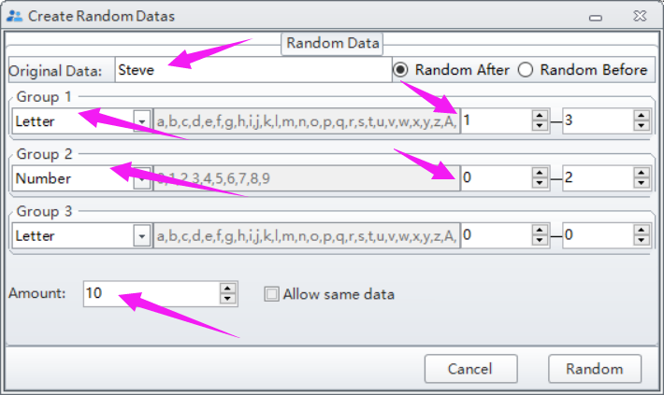
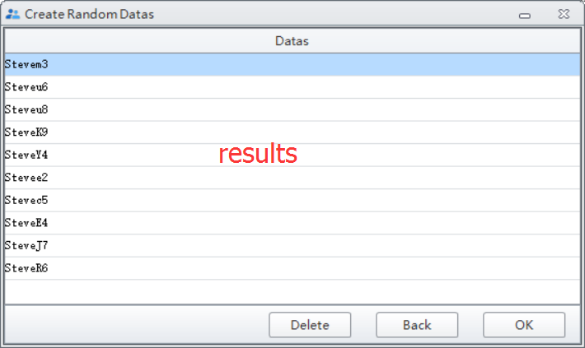

Note: please do not forget to click “Create Account” button to save the data you entered/modified.
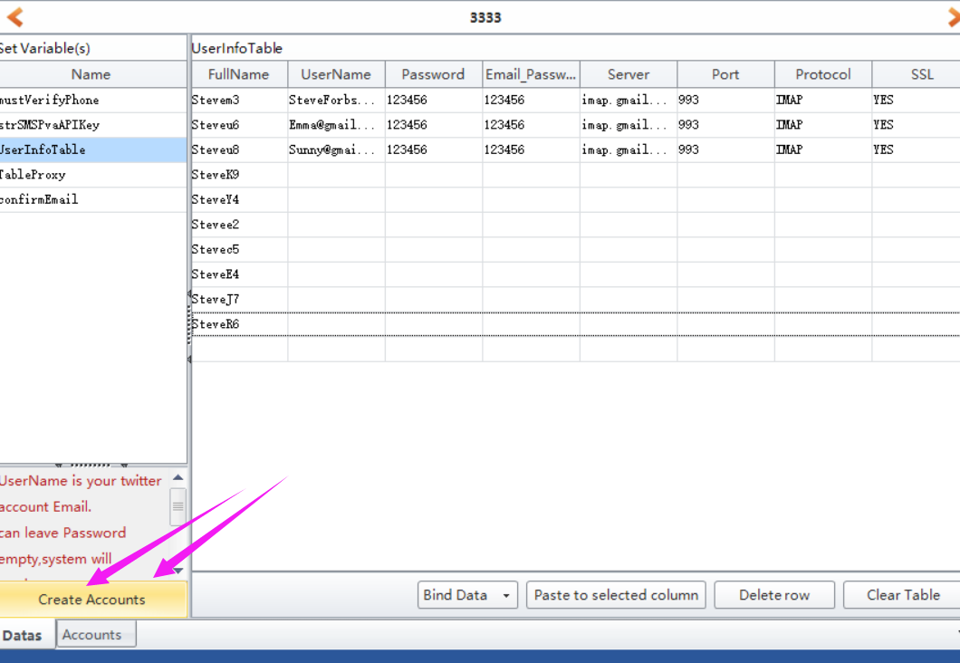

Where to find the data i entered?
Click Accounts button, then you can find all data you entered in this form:
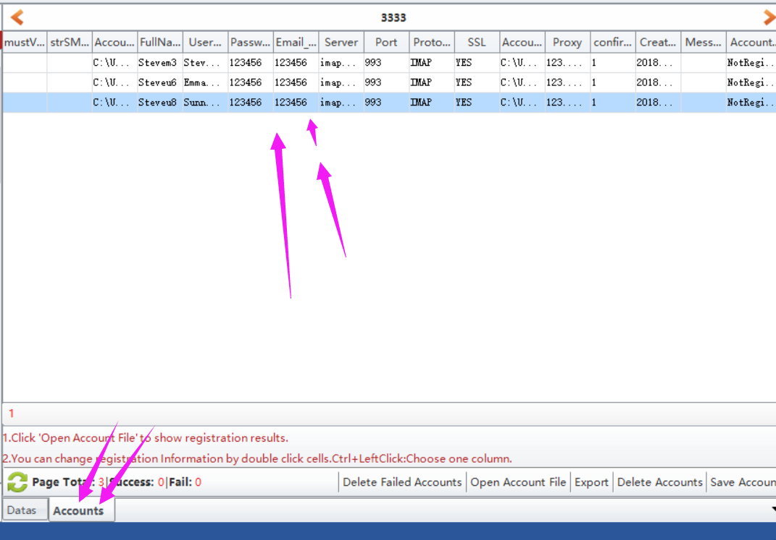

Where to start to run the task?
Click Start button to run.
